Resource use application form

Research Imaging and Clinical Physiology Service

— Includes echocardiogram, MRI, VO₂max and DEXA

Resource use application approval (office use)
Date:
Approval – Head, Clinical Research
Signed:
Name: | A/Professor Andre La Gerche
Approval – Baker Institute practitioner
(radiographer, sonographer, physiologist, cardiologist – as applicable)
Signed:
Name: | Mr Michael Sellenger
Section 1: Project details
Title:
Name of HREC:
Study number:
Chief Investigator:
Research organisation:
Email:
Phone:
Expected commencement date:
Expected completion date:
Brief summary of Project Services: (2 lines)

Section 2: Payment details for service
Baker Institute studies
Cost centre:
Project code:
Source of funding for this project:
(e.g. NHMRC project grant number)
External studies
Name of contact for payment:
School/Centre:
Faculty/Institute:
University/Organisation:
Email:
Phone:
Section 3: Investigations
Anticipated number of study participants:

Scans | No. of participants | Scans / tests per participants | Duration between scans / scans | Total No. of  scans / tests for project | Cost quoted by Clinical Research Department (per scan/test)
Transthoracic Echocardiogram |  |  | weeks/months
MRI |  |  | weeks/months
Vo2 Max |  |  | weeks/months
DEXA |  |  | weeks/months
Other – please state |  |  | weeks/months

Specific details for echocardiograms and DEXA
Can participants be bulk billed for their scans? Yes / No

Specific details for MRI scans
Please discuss with the Baker radiographer on duty and confirm the following. Ensure details cited are approved by the radiographer.
MRI scan time incl. time for preparation and post scan: ______________________________
Is Imaging Protocol attached to this form? | Yes Approval required-  - Baker radiographer to sign:
Is a MRI WIP required? No | Yes Approval required-  - Baker radiographer to sign:
Is an IV contrast required? No | Yes Approval required  - Baker radiographer to sign:
NB: The study investigator must liaise with the Baker radiographer/s early to ensure that an MRI protocol (which is separate to the main study protocol) is developed and finalised PRIOR to the study commencing.

Specific details for external studies — Items provided by the research organisation
Please specify any materials or items to be supplied by the Research Organisation to enable the scans to proceed:

Please list all MRI sequence algorithms to be used in the study:

Section 4: Investigators
Please specify details for each investigator who wishes to enter the scanner room. Please add extra pages if more than two investigators will be entering the scanner room.
Investigator No. 1
Name:
Email:
Phone:
Investigator No. 2
Name:
Email:
Phone:
Section 5: Reporting
Is there a requirement for incidental finding to be reported?
No
Yes
Please include the Contact Person for Incidental Finding below:
Name: _____________________________________________
Phone: _____________________________________________
Email: _____________________________________________

Section 6: Ethics approval
Once ethics approval is obtained, please provide:
- Copy of this form, HREC approval and Protocol to governance
governance@baker.edu.au
- Copy of this form and expected date to commence studies to Clinical Research Department saba.seifi@baker.edu.au; OR if Alfred Health researcher, to Radiology Research Unit H.Kavnoudias@alfred.org.au
Section 7: Location of the Baker Institute Research Imaging and Clinical Physiology Service
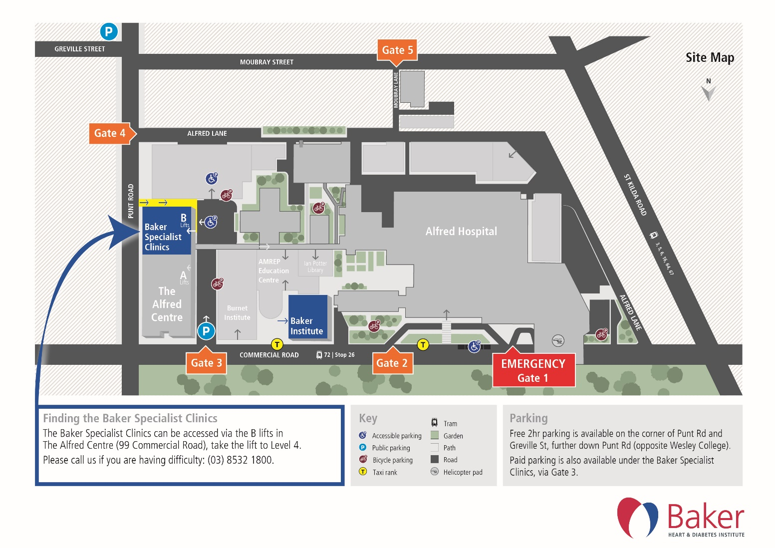
Version
Custodian | Created | Last review | Next review | Date of effect
Clinical Research Department | February 2018 | December 2018 | December 2019 | December 2018

