Resource Use Application Form

Research Imaging and Clinical Physiology Service

includes echocardiogram, exercise ECG, ECG, MRI, VO₂max and DEXA

☐ Hopper Crossing ☐ Alfred Centre

Resource use application approval
Date:
Approval – Head, Cardiometabolic Health and Exercise Physiology Lab (All services including CPET/VO₂max, Dexa)
Signed:
Name: | A/Prof. Erin Howden
Acknowledged Approval – - Head of Cardiovascular Clinical Services (Echo, Holter, ECG, BP Monitor)
Signed:
Name: | Dr. Kegan Moneghetti
Acknowledged Approval – Head, Cardiovascular MRI (MRI services)
Signed:
Name: | Dr. Sarah Gutman
Acknowledged Approval - Senior MRI radiographer – (MRI services)
Signed:
Name:
Section 1: Project details
Title:
Name of HREC:
Study number:
Chief Investigator:
Research organisation:
Email:
Phone:
Expected commencement date:
Expected completion date:
Briefly describe proposal, including experimental procedure to be used (min. 25 words):

Section 2: Payment details for service
Baker Institute studies
Cost centre:
Project code:
Source of funding for this project:
(e.g. NHMRC project grant number)
External studies
Name of contact for payment:
School/Centre:
Faculty/Institute:
University/Organisation:
Email:
Phone:

Section 3: Investigations
Anticipated number of study participants:
Expected duration of study:

Scans | No. of participants | Scans / tests per participants | Duration between scans / scans | Total No. of  scans / tests for project | Cost quoted by Clinical Research Department (per scan/test)
Echocardiogram |  |  | weeks/months
EGC |  |  | weeks/months
MRI |  |  | weeks/months
CPET |  |  | weeks/months
DXA |  |  | weeks/months
Other – please state |  |  | weeks/months
Specific details for echocardiograms
Can participants be bulk billed for their scans? Yes / No
Specific details for MRI scans
Please discuss with the Baker radiographer on duty and confirm the following. Ensure details cited are approved by the radiographer.
MRI scan time incl. time for preparation and post scan: ______________________________
Is Imaging Protocol attached to this form? | Yes Approval required-  - Baker radiographer to sign:
Is a MRI WIP required? No | Yes Approval required-  - Baker radiographer to sign:
Is an IV contrast required? No | Yes Approval required  - Baker radiographer to sign:
NB: The study investigator must liaise with the Baker radiographer/s early to ensure that an MRI protocol (which is separate to the main study protocol) is developed and finalised PRIOR to the study commencing.

Specific details for external studies — Items provided by the research organisation
Please specify any materials or items to be supplied by the Research Organisation to enable the scans to proceed:
Please list all MRI sequence algorithms to be used in the study:

Section 4: Investigators
Please specify details for each investigator who wishes to enter the scanner room. Please add extra pages if more than two investigators will be entering the scanner room.
Investigator No. 1
Name:
Email:
Phone:
Investigator No. 2
Name:
Email:
Phone:
Section 5: Reporting
Is there a requirement for incidental finding to be reported?
No
Yes
Please include the Contact Person for Incidental Finding below:
Name: _____________________________________________
Phone: _____________________________________________
Email: _____________________________________________

Section 6: Ethics approval

Once ethics approval is obtained, please provide:

- Copy of this form, HREC approval and Protocol to governance
governance@baker.edu.au and contracts.manager@baker.edu.au
- Copy of this form and expected date to commence studies to Cardiometabolic Health and Exercise Physiology Lab, Des.Fankhauser@baker.edu.au; OR if Alfred Health researcher, to Radiology Research Unit H.Kavnoudias@alfred.org.au

Section 7: Location of the Baker Institute Research Imaging and Clinical Physiology Service
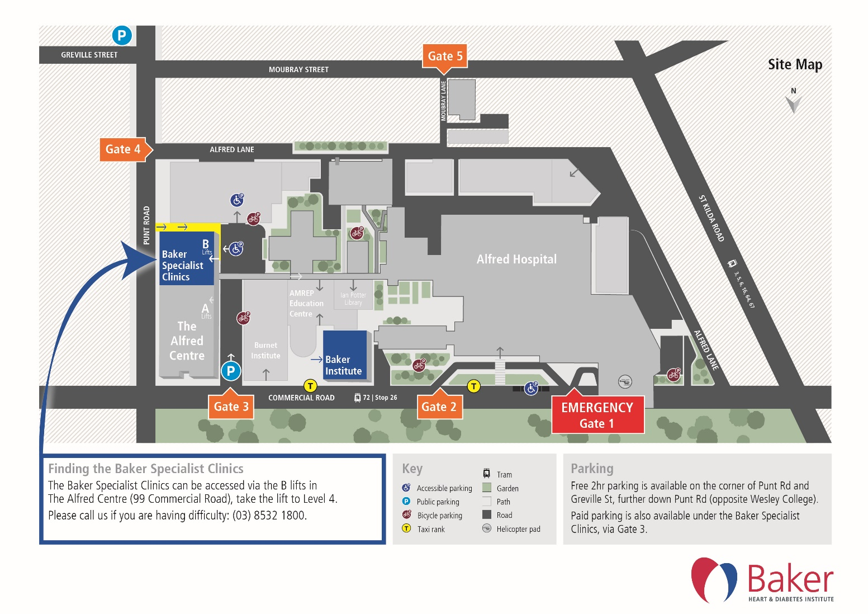

Version
Custodian | Created | Last review | Next review | Date of effect
Cardiometabolic Health and Exercise Physiology Lab | February 2018 | January 2024 | January 2025 | January 2024

