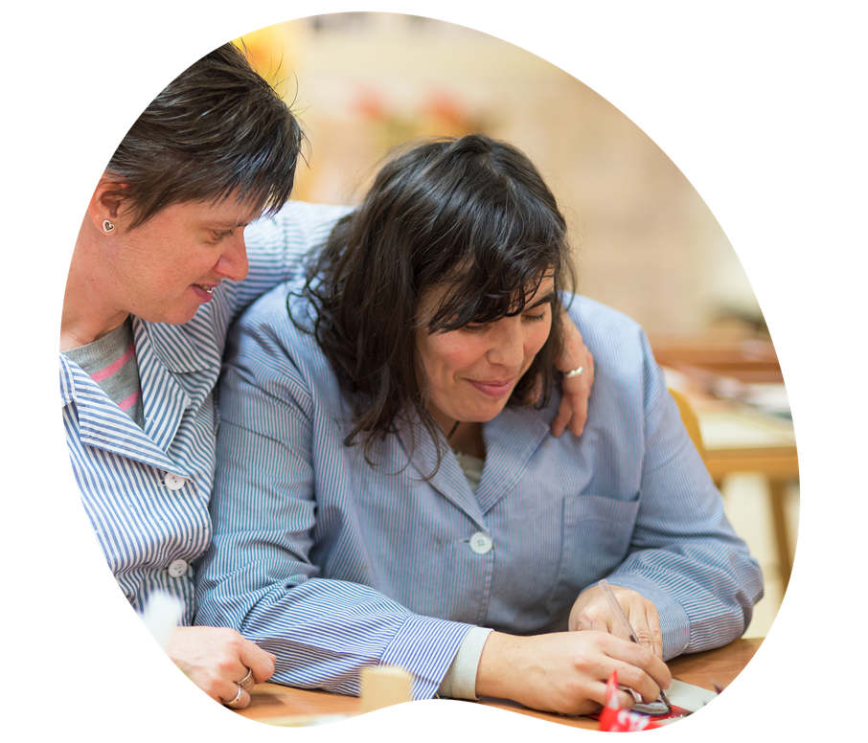

Improving Hospitals for People with Hidden Disabilities

SPEAK Project

Co-design Report

November 2022

Alfred Health respectfully acknowledges the Traditional Custodians of this land, the people of the Kulin Nations

We pay our respect to their Elders, past and present

We acknowledge and uphold their continuing connection to land and waterways

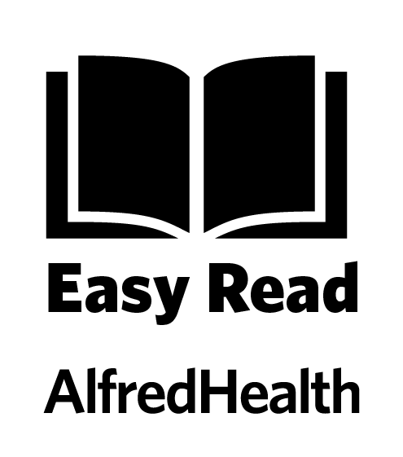

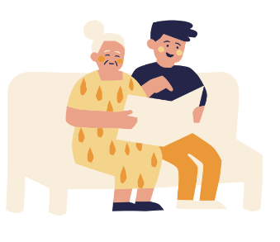

You are reading this document in Easy Read.

This booklet is designed as a co-read guide for supported reading.

We encourage supporters to read along with people with disabilities to assist with understanding.

Improving Hospitals for People with Hidden Disability

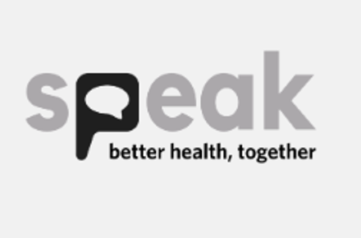

The SPEAK Project is improving hospitals for people with disability.

Alfred Health and South West Healthcare are working together to deliver the SPEAK Project

What is this document?

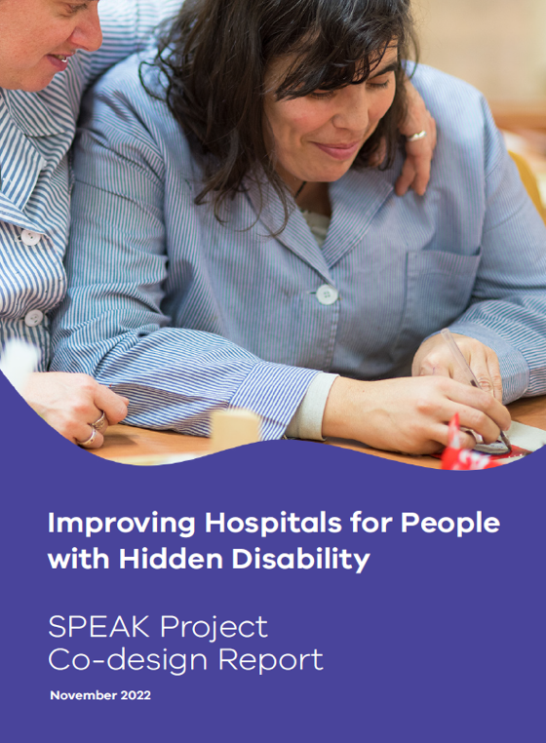

This document is a summary of the report called:
- Improving hospitals for people with hidden disability

The report is about how we can improve hospitals for people with disability.

The report is written by SPEAK Project team.

How was the report made?

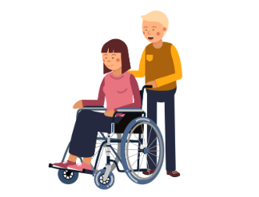

We used Co-design to make the report
Co-design is a way to share decisions together

We did co-design with
- 41 people with disability
- 12 support people
We will say people with disability for short

We asked people with disability
- What it was like going to hospitals
- How to improve hospitals

What it was like going to hospitals?

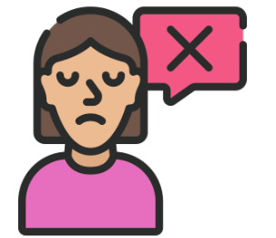

We asked people with disabilities what it was like going to hospitals

People with disabilities said they had a hard time in hospital

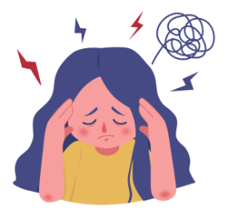

People with disabilities did not feel respected in hospitals

People with disabilities felt stressed in hospital environments

People with disabilities felt hospitals were not fair and equal

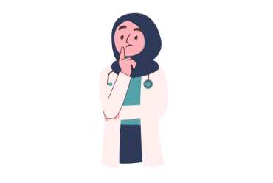

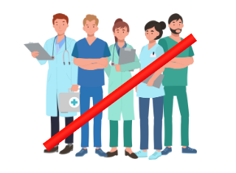

Hospitals sometimes ignore carers and families

Staff are not sure how to support people with disabilities

Hospitals do not train staff to support people with disabilities

How to improve hospitals?

We asked people with disabilities how to improve hospitals

People with disabilities told us ideas about making hospital better

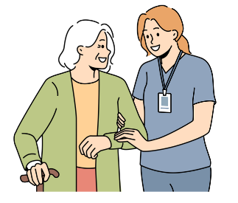

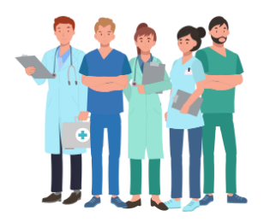

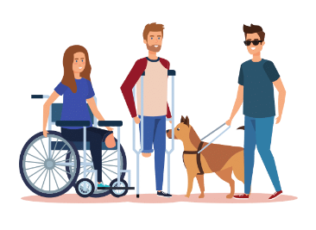

Hospitals should have specialist staff to support people with disabilities

Specialist staff are people who understand disability and the hospital

All hospital staff should be trained on how to support people with disabilities

People with disabilities should train hospitals on how to support people with disabilities

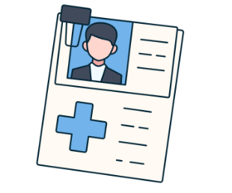

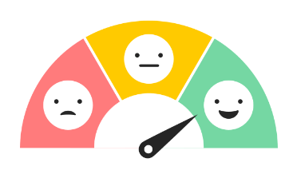

Hospitals should add support information to the medical records of people with disabilities

Hospitals should have important information in Easy English

Hospitals should make it easy to give feedback

