Creative Activities Conversation Starter Cards
You can use the creative activities cards to plan or start conversations. If you can think of others, please add your own cards to The Guide.
When you are planning activities, consider the following:
- The activity examples are given to help get you started.
- Try and find other activities that work for your project and participants.
- Look for activities and ideas that help your participants think in different ways.
- Find ways to change activities to build on the strengths of your participants.

Getting to know each other

Aim:
To build relationships and find common connections.

Steps:
- Break the group up into pairs
- Invite participants to discuss a question. Some examples could be:
    - What does community mean to you? What does community feel like?
    - Why is this co-design project important to you? What do you want to give to the project?
- Invite people to share (if they are comfortable) what they learned from each other
- Make sure you leave plenty of time. Don't rush conversations.

Getting to know each other

Aim:
To build relationships and find common connections.

Steps:
- Consider bringing together the co-design group for a morning tea.
- Break the group up into pairs.
- Invite participants to share why they want to be a part of the co-design project.
- Encourage storytelling, but do not try a force it.

Warming up at the start of a workshop (1 of 2 cards)

Aim:
To focus on participants' strengths and build confidence.

Steps:
- As the group, the below question:
    - What is something that you are proud of about advocating for yourself, someone you care for, or the disability community?
  - Ask the group who is comfortable sharing their answers.

Warming up at the start of a workshop (1 of 2 cards) 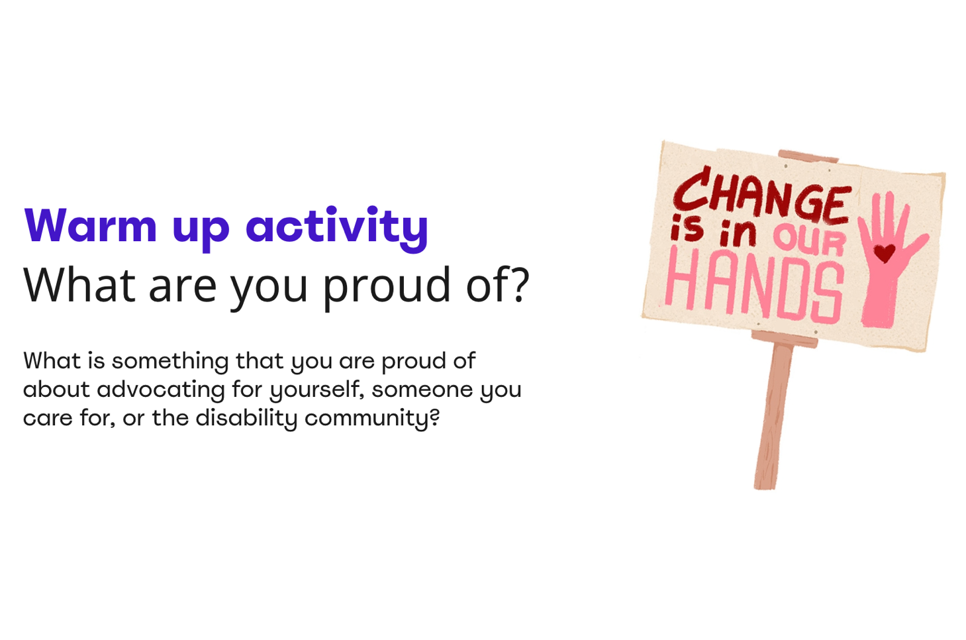

Sharing research (1 of 2 cards)

Activity name:
Research Gallery

Aim:
To share research or background information with participants in an accessible and creative way.

Steps:
  - Review the research you have that supports your project.
  - Make sure the written content is in plain language.

Sharing research (2 of 2 cards)

Steps continued:
  - Design parts of your research content in different formats, such as:
    - pictures, diagrams, or drawings
    - large posters with important statements about what the research shows
    - audio recordings of important information, quotes, or stories
    - video team members and other people sharing what the information means to them
    - brainstorm with your team other creative ways to communicate your research
  - Create a display or exhibition of your designed research content.
  - Invite participants to move around the room in their own time and discuss what they think with each other (make sure the room is clear of tables for easy access)

Coming up with ideas (Journey Map 1 of 2 cards)

Activity name:
Journey map

Aim:
To explore all the steps of using your service and find areas to improve.

Steps:
- Decide together on what the journey is about. For example, going to the hospital.
- Decide together who we are focusing on. For example, an autistic person going to the hospital or a carer supporting someone who is going to the hospital.
- Add the main steps of the journey. For example, coming to the hospital, staying in the hospital, and going home.

Coming up with ideas (Journey Map 2 of 2 cards)

Steps continued:
- Describe what happens at each step. Discuss the staff we meet, the things we need, and the steps in each stage.
- Add at each stage how the person is feeling and what is making it hard or easy to use the service.
- There are many ways to design how your journey map looks. Try this template to get started at this link on the Service Design Tools website

Coming up with ideas (Scenario 1 of 2 cards)

Activity name:
Scenario

Aim:
To focus on a situation in your service or using a thing (e.g., product or website). Discuss how to make the situation better for people.

Steps:
- Decide together what you are trying to make better. For example, giving feedback on a service.
- Describe the scene, including the following:
    - Who is the main person that is in our scene, and what are they trying to do?
    - Where is this scene happening? For example, is it in person or online?
    - Describe what is happening step by step.

Coming up with ideas (Scenario 2 of 2 cards)

Steps continued:
- Describe who else is there interacting with our main person. For example, staff or support workers.
- Add drawings and pictures of the scene to help make the scene feel real. The below image shows images found on the internet to make the scene of giving feedback feel real.
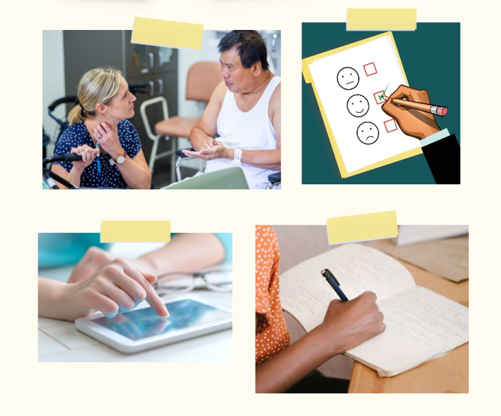

Testing ideas (Storyboard 1 of 2 cards)

Activity name:
Storyboard

Aim:
To help you visualise your idea from start to finish. A creative way to share your idea with other people to get feedback.

Steps:
- Decide together what part of your idea you want to storyboard and test.
- Drawing how your idea works. Use a series of comic book-style frames for your drawing.
- Think about including someone who is good at drawing and have participants tell them what to draw.

Testing ideas (Storyboard 1 of 2 cards)
A storyboard can be simple or full of detail. Below is an example of what storyboards can look like.
